Bootstrap 4 Grid

* **HORIZONTAL ALIGNMENTS**

my-container, my-col, and my-row are custom CSS classes just to add border.

**“col”** **class** divides the space equally and if it single column, it will take the entire space

**Example:**



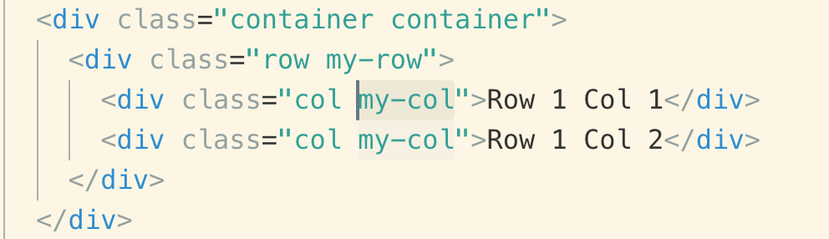

You can specify the size of the column by adding a number from 1 - 12

**Note:** for different screen sizes you can add classes like

“col-md-4”

“col-sm-4”

“Col-lg-4”

**Example:**



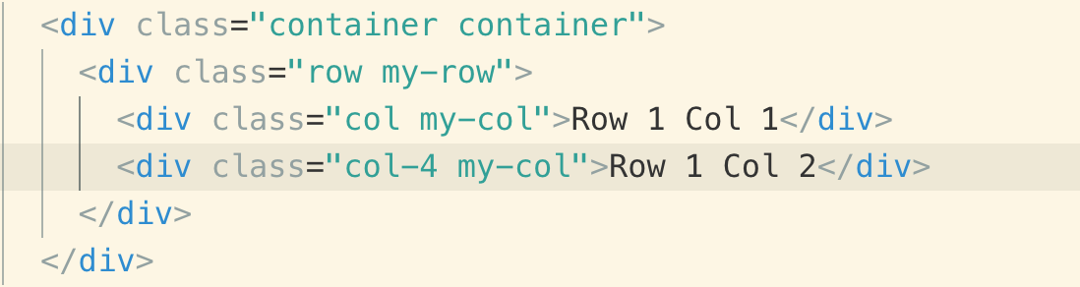

To center 2 columns horizontally we use these classes.

**Note:** These classes are used in **“row”**

1. justify-content-center
2. Justify-content-start
3. Justify-content-end
4. Justify-content-around
5. Justify-content-between

Let’s use the above classes one by one.

To display the row columns in the center by using “justify-content-center”

**Example:**



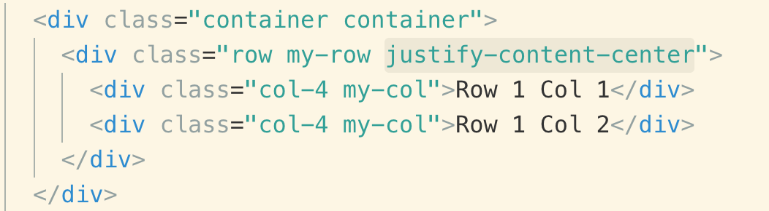

To display the row columns in the start by using “justify-content-start”



To display the row columns in the center by using “justify-content-end”



To display the row columns in the end by using “justify-content-end”



If you want 2 columns to be placed at the start and end “justify-content-between”



If you want 2 columns to take equal space justify-content-around

**Note:** you will see middle space is bigger than the left and right that is because it adds equal space to the right and left side of the column



* **VERTICAL ALIGNMENT**

**Note:** These classes are used in **“row”**

1. align-item-center
2. align-item-start
3. align-item-end
4. align-item-stretch

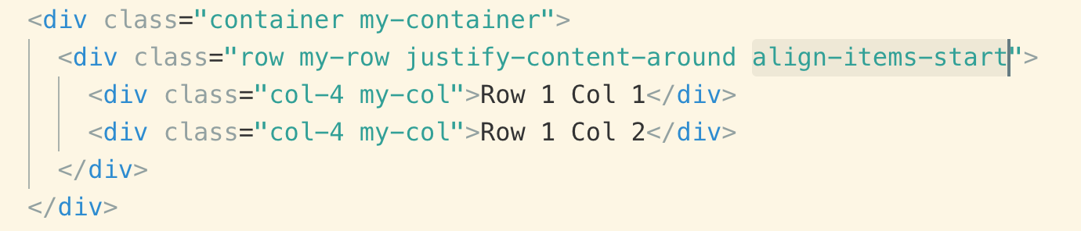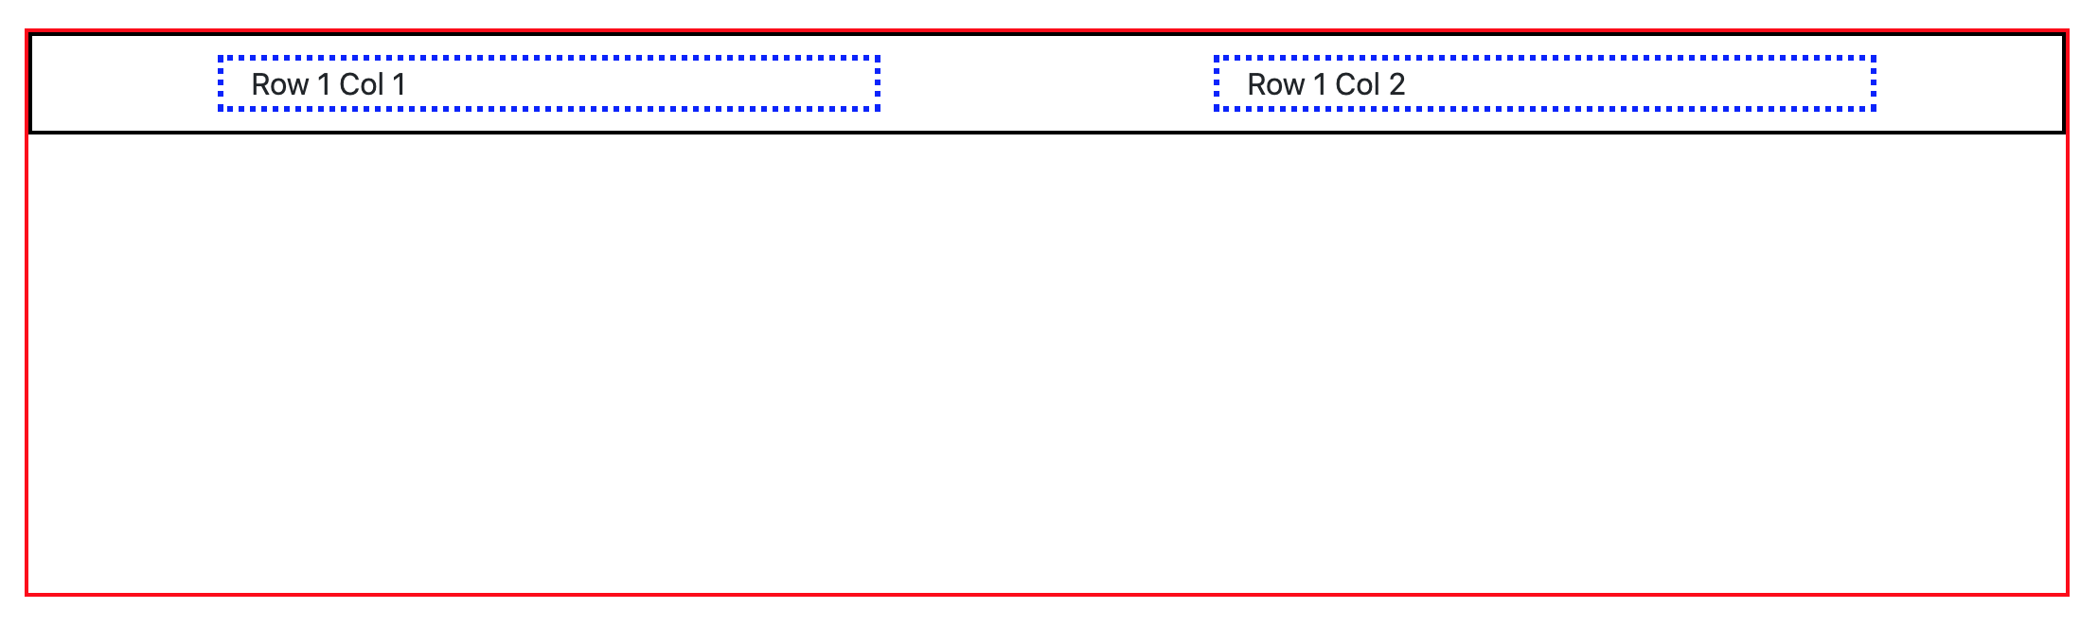

To display the row columns at the bottom “align-item-end”

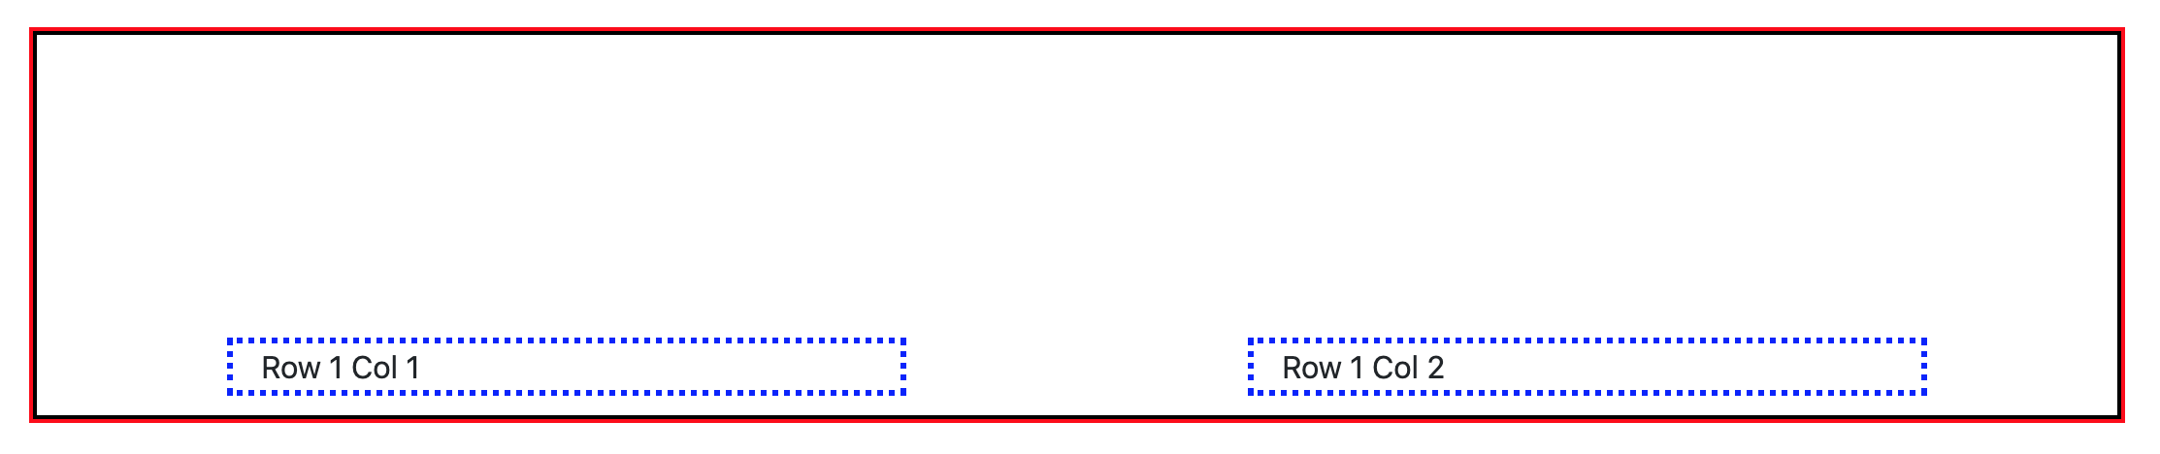

To display the row columns at the bottom “align-item-center”

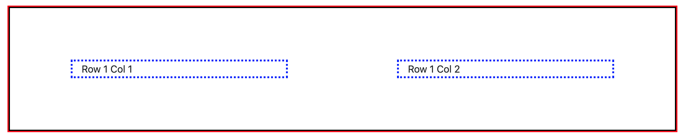

To make the row columns take the entire height “align-item-stretch”

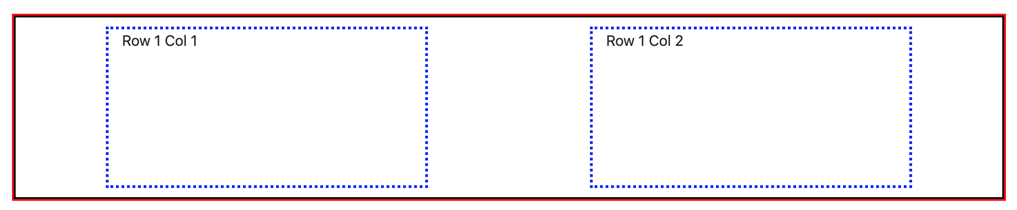

* **COLUMN VERTICAL PLACEMENT CLASSES**

**Note:** These classes are used in **“col”**

1. align-self-center
2. align-self--start
3. align-self--end
4. Align-self--stretch

Vertical alignment of a specific column to put it to start “align-self--start”

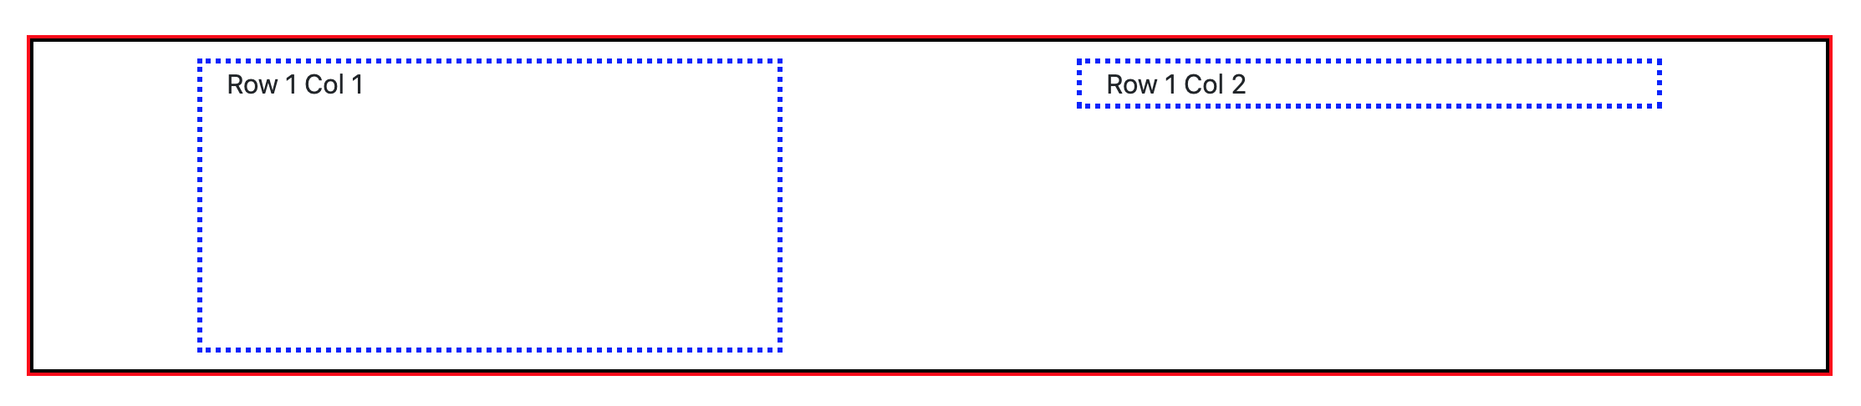

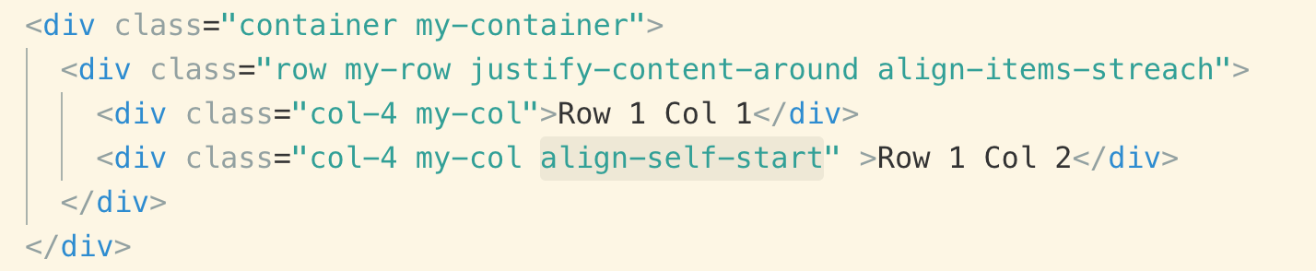

* **COLUMN HORIZONTAL ORDER CLASSES**

**Note:** This class is used in **“col”.** You can give number from 1 - 12, smaller will come first.

1. order-1
2. order-md-1

You can see the columns 2 moves to first in order

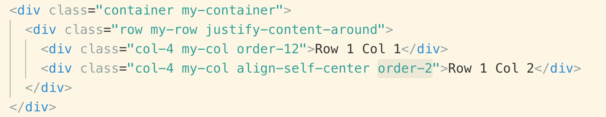

* **COLUMN OFFSET**

**Note:** This class is used in **“col”.** You can give number from 1 - 12

Offset-2 => This simply means that move “Row col 2” two columns right

offset-md-2

